**Report on Performing Principle Component Analysis on a Geochemical Dataset**

**Rakibul Hasan Badhon**

**M.S. in Geophysics 2022-23**

**Step 1-** #Importing the geochemical dataset in R, getting summary, head and dimention of the dataset

nashville <- read.table(file='NashvilleCarbonates.csv', header=TRUE, row.names=1, sep=',')

summary(nashville)

head(nashville)

dim(nashville)

**Result of Step1-**

> summary(NashvilleCarbonates)

...1 StratPosition d13C d18O Al Ca

Length:200 Min. :32.25 Min. :-0.6100 Min. :-5.380 Min. : 1.240 Min. :191.3

Class :character 1st Qu.:32.85 1st Qu.: 0.5675 1st Qu.:-4.452 1st Qu.: 2.663 1st Qu.:271.9

Mode :character Median :33.45 Median : 0.9300 Median :-4.160 Median : 3.345 Median :293.4

Mean :33.49 Mean : 0.8975 Mean :-4.225 Mean : 3.878 Mean :291.0

3rd Qu.:34.05 3rd Qu.: 1.2200 3rd Qu.:-3.960 3rd Qu.: 4.455 3rd Qu.:316.5

Max. :35.08 Max. : 1.9500 Max. :-3.280 Max. :20.870 Max. :390.8

Fe Mg Mn Si

Min. : 1.000 Min. : 0.750 Min. :0.0300 Min. : 1.960

1st Qu.: 2.200 1st Qu.: 3.317 1st Qu.:0.0700 1st Qu.: 5.975

Median : 2.695 Median : 3.785 Median :0.0900 Median : 7.980

Mean : 4.134 Mean : 4.505 Mean :0.1592 Mean : 9.370

3rd Qu.: 3.908 3rd Qu.: 4.740 3rd Qu.:0.1800 3rd Qu.:10.485

Max. :46.030 Max. :13.900 Max. :0.9500 Max. :54.210

> head(NashvilleCarbonates)

# A tibble: 6 × 10

...1 StratPosition d13C d18O Al Ca Fe Mg Mn Si

*<chr>* *<dbl>* *<dbl>* *<dbl>* *<dbl>* *<dbl>* *<dbl>* *<dbl>* *<dbl>* *<dbl>*

1 Ae 35.1 1.95 -4.66 1.49 297. 1.52 2.22 0.34 8.61

2 Ad 34.7 1.82 -4.57 2.73 276. 2.7 2.84 0.33 7.32

3 Ac 34.7 1.91 -4.77 4.26 328. 3.13 3.12 0.4 9.65

4 Ab 34.6 0.93 -4.58 4.69 330. 9.11 2.88 0.47 23.1

5 Aa 34.3 -0.34 -4.54 4.8 286. 3.46 3.69 0.45 9.97

6 A1 34.2 0.46 -3.86 3.89 347. 3.79 8.77 0.32 7.98

> dim(NashvilleCarbonates)

[1] 200 10

**Analysis-** The summary of the dataset includes the min, max, 1st quartile, 3rd quartile, median, mean values of the dataset. The head defines a small portion of the dataset to overview it. The dimention code shows that the number of rows and column of the dataset is 200X10 or 200 rows and 10 columns.

**Step 2-** #Histogram analysis from the given dataset of each chemical data by eliminating the 1st row which defines headers.

geochem <- nashville[ , 2:9]

par(mfrow=c(2,4))

hist(geochem$d13C, main= "Histogram of d13C", xlab= "Concentration")

hist(geochem$d18O, main= "Histogram of d18O", xlab= "Concentration")

hist(geochem$Al, main= "Histogram of Al", xlab= "Concentration")

hist(geochem$Ca, main= "Histogram of Ca", xlab= "Concentration")

hist(geochem$Fe, main= "Histogram of Fe", xlab= "Concentration")

hist(geochem$Mg, main= "Histogram of Mg", xlab= "Concentration")

hist(geochem$Mn, main= "Histogram of Mn", xlab= "Concentration")

hist(geochem$Si, main= "Histogram of Si", xlab= "Concentration")

**Result-** 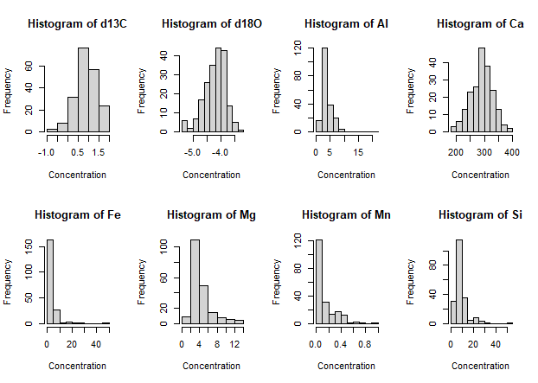

**Analysis-** From the histogram data, it can be seen that the datas are skewed. To reduce the skewness we need to perform 10 based logarithmic analysis to the dataset.

**Step 3-** # Performing logarithmic analysis on the dataset and histogram of it.

geochem[ , 3:8] <- log10(geochem[ , 3:8])

par(mfrow=c(2,4))

hist(geochem$d13C, main= "Histogram of d13C", xlab= "Concentration")

hist(geochem$d18O, main= "Histogram of d18O", xlab= "Concentration")

hist(geochem$Al, main= "Histogram of Al", xlab= "Concentration")

hist(geochem$Ca, main= "Histogram of Ca", xlab= "Concentration")

hist(geochem$Fe, main= "Histogram of Fe", xlab= "Concentration")

hist(geochem$Mg, main= "Histogram of Mg", xlab= "Concentration")

hist(geochem$Mn, main= "Histogram of Mn", xlab= "Concentration")

hist(geochem$Si, main= "Histogram of Si", xlab= "Concentration")

**Result-**

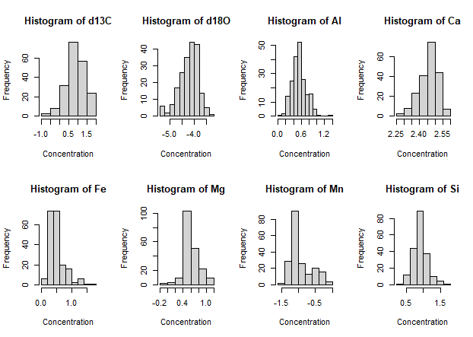

**Analysis-** After performing the log analysis it can be seen that the datas are now less skewed and have a trend to be symmetrical.

**Step 4-** # Performing principle component analysis on the geochemical data and getting loadings, variance, and scores.

pca <- prcomp(geochem, scale.=TRUE)

variance <- (pca$sdev)^2

loadings <- pca$rotation

rownames(loadings) <- colnames(geochem)

scores <- pca$x

head(scores)

head(loadings)

head(pca)

head(variance)

**Result-**

> head(scores)

PC1 PC2 PC3 PC4 PC5 PC6 PC7 PC8

Ae 0.99895862 -2.9495309 1.3801629 0.7421200 -0.474085530 -1.1389195 0.5055317 -0.94129775

Ad -0.19417133 -2.1591398 1.1695315 0.8787195 -0.006140004 -0.5011314 0.3481612 0.01266002

Ac -0.82681918 -2.1294639 2.0272174 -0.4054445 -0.626770366 -0.2992604 0.2388330 0.48337275

Ab -2.45369359 -1.5254006 0.5933249 -2.0133425 0.014289439 -0.4027581 -0.7715476 -0.53717437

Aa -0.71301041 -0.6076674 -0.9985795 -2.1838599 1.774119430 -0.2477416 0.7496759 0.45296081

A1 -0.03577491 1.2165676 1.4278173 -1.4484897 1.625648643 0.0488706 -0.3170885 -0.17330717

> head(loadings)

PC1 PC2 PC3 PC4 PC5 PC6 PC7 PC8

d13C -0.17093261 -0.22894417 0.64052380 0.57094785 -0.4179927 -0.05778053 -0.06353101 0.004662106

d18O 0.04711531 0.60122628 0.05824626 0.25679201 0.2360601 -0.55394501 -0.45048603 -0.038147737

Al -0.50296376 0.29293715 0.03299936 -0.18402480 -0.1628328 -0.04798452 0.14714278 0.758810356

Ca 0.33322597 0.04152916 0.47485138 -0.65202938 -0.2646605 0.03320641 -0.40372774 0.049655863

Fe -0.53032325 -0.08597010 -0.09730983 0.01094017 0.1637302 0.47243386 -0.66168198 -0.118123344

Mg -0.06073680 0.55216521 0.44152752 -0.00419661 0.2694198 0.47529055 0.36370902 -0.256296844

> head(pca)

$sdev

[1] 1.6931670 1.4669843 1.0191118 0.9361737 0.7172379 0.5184617 0.4611792 0.2649783

$rotation

PC1 PC2 PC3 PC4 PC5 PC6 PC7 PC8

d13C -0.17093261 -0.22894417 0.64052380 0.57094785 -0.4179927 -0.05778053 -0.06353101 0.004662106

d18O 0.04711531 0.60122628 0.05824626 0.25679201 0.2360601 -0.55394501 -0.45048603 -0.038147737

Al -0.50296376 0.29293715 0.03299936 -0.18402480 -0.1628328 -0.04798452 0.14714278 0.758810356

Ca 0.33322597 0.04152916 0.47485138 -0.65202938 -0.2646605 0.03320641 -0.40372774 0.049655863

Fe -0.53032325 -0.08597010 -0.09730983 0.01094017 0.1637302 0.47243386 -0.66168198 -0.118123344

Mg -0.06073680 0.55216521 0.44152752 -0.00419661 0.2694198 0.47529055 0.36370902 -0.256296844

Mn -0.23413236 -0.42267804 0.38936540 -0.21022540 0.6682850 -0.33497790 0.10037937 0.042826775

Si -0.51458764 0.08741098 -0.06117739 -0.32363090 -0.3563686 -0.35368926 0.16791587 -0.582055689

$center

d13C d18O Al Ca Fe Mg Mn Si

0.8975000 -4.2251000 0.5441228 2.4600622 0.5057957 0.6078496 -0.9294834 0.9113662

$scale

d13C d18O Al Ca Fe Mg Mn Si

0.51600003 0.38549842 0.18872135 0.05911655 0.26096082 0.19706381 0.31372717 0.21872613

$x

PC1 PC2 PC3 PC4 PC5 PC6 PC7

Ae 0.99895862 -2.949530852 1.38016287 0.742119953 -0.474085530 -1.138919511 0.505531662

Ad -0.19417133 -2.159139774 1.16953152 0.878719537 -0.006140004 -0.501131410 0.348161169

Ac -0.82681918 -2.129463941 2.02721742 -0.405444455 -0.626770366 -0.299260357 0.238832969

Ab -2.45369359 -1.525400622 0.59332488 -2.013342528 0.014289439 -0.402758125 -0.771547644

Aa -0.71301041 -0.607667378 -0.99857950 -2.183859899 1.774119430 -0.247741597 0.749675875

A1 -0.03577491 1.216567550 1.42781729 -1.448489738 1.625648643 0.048870602 -0.317088526

A2 0.30798049 0.525571168 0.27355589 -0.264071396 1.292650449 -0.242219196 -0.034053006

A3 0.18588513 0.624599434 0.35663160 0.012175216 0.278375286 0.293747204 -0.014143821

A4 1.10009641 -0.108353277 0.13416646 -0.139414253 0.003756074 0.200424445 -0.310389370

A5 -1.22090026 0.745520613 0.96572092 -2.207538048 -1.465760001 -0.496563386 0.222887157

A6 -0.09394794 -0.146618220 -0.89179355 0.766093702 -0.058022269 -0.154605651 0.350528869

A7 0.68251434 -0.417345914 -0.78345393 0.821488458 -0.465852177 -0.551631253 0.511203108

A8 1.97133394 0.343988965 -0.63418072 0.462607030 0.224995867 -0.360940821 -0.267160514

A9 -1.52165635 1.470720495 -0.76373423 -1.332654858 -1.589947599 -0.410707013 0.244959858

A10 2.29046854 0.100592796 -0.07759089 -0.568090256 0.264032902 0.105147727 -0.279764326

A11 1.67967624 0.682025357 0.73107421 0.379271219 0.028432799 0.042603821 -0.487482861

A12 1.73680663 1.322947446 -0.71232861 -0.545526399 1.779367180 1.352046550 0.494524818

A13 2.18995540 -0.636884995 -1.41552647 -0.608239614 0.056255508 0.411619998 0.543123877

A14 2.04615596 0.252396179 -0.55853776 -0.656592454 -0.315324762 0.169488489 0.056497738

A15 0.29145591 0.509260505 -0.32415727 -0.132504371 -0.334770930 0.268778369 -0.302917134

A16 0.33588599 0.284535624 -1.10766999 1.369147129 -0.390567472 0.131011730 0.365180471

A17 -0.44455663 0.224755067 0.31993795 0.109607773 -0.379936860 0.623319427 -0.246889450

A18 -0.14744010 0.299573634 0.24482727 0.102207879 -0.625816483 0.322708877 0.055022445

A19 -0.50551688 1.022828062 1.03007451 -0.006812894 -0.629006309 -0.026882887 -0.429952933

A20 -0.42562571 1.232360521 1.25586320 -0.601051073 -0.707693663 0.067216319 -0.671532656

Be -1.59414163 -2.730198432 1.51243555 -0.345572310 -0.312880512 0.483911685 0.058453030

Bd -1.20262790 -1.251859681 0.94570090 -0.302235523 0.088163980 -0.827259801 0.655082823

Bc -1.49219190 -1.513569242 1.26142333 0.069978992 -0.369023196 -0.748129566 0.249516768

Bb -4.40486312 -2.139326423 -1.65743486 -0.804050582 -0.153852738 -0.056448172 -0.664319596

Ba -4.26718864 -3.417350770 -2.01699340 -1.374115851 0.858540449 0.373357441 0.273779102

B1 -0.78267353 0.113134809 1.33551517 0.865362891 1.304255915 -0.555581324 0.725306320

B2 0.34177060 0.651398710 -0.42637253 -0.069756772 0.319567176 -0.631818730 -0.046697696

B3 0.90877262 0.491462977 -0.34631893 -0.331410422 -0.342474975 -0.041058277 -0.226894287

B4 0.53904204 -0.043960015 -0.06144536 0.156409212 -0.584727897 -0.054180373 -0.030139166

B5 0.81184084 -0.729768743 0.18806176 -0.418675044 -0.621880368 0.348915373 0.161925567

B6 0.51791790 -0.283365164 0.43255739 -0.637503460 -0.955317579 -0.244606462 0.143480510

B7 -1.06447135 0.097538875 -0.68798201 0.250932148 -0.835221839 -0.693066780 0.547489034

B8 1.16864154 0.910736952 -1.19718753 -0.622641158 -0.052055698 -0.390130595 -0.295011536

B9 0.03807951 0.416267802 -0.54344740 -1.667766958 -0.558721047 0.394521816 0.097647681

B10 1.40857133 0.400339600 -1.03416644 0.727346998 -0.463489190 -0.542425430 0.116969957

B11 1.21548028 0.547397178 -0.49336131 0.901881344 -1.055453709 -0.391401369 -0.094093963

B12 0.67328964 0.785020322 -0.04849593 0.426500860 -1.017922887 -0.421176921 -0.404494349

B13 1.37187128 0.357629095 -0.32119345 -1.104240335 -0.157741778 0.226560755 0.280245546

B14 1.43214463 1.111794271 -0.13669828 0.060577734 -0.344267489 -0.617319901 -0.180538683

B15 0.12599780 0.815078779 -1.28222689 -0.556188651 0.115141972 0.078835011 -0.141822492

B16 -2.08096414 1.412778441 0.05586670 -0.343569433 -0.358765253 0.429416481 0.197621407

B17 -0.95912219 1.441678474 0.76672795 -1.028075131 -0.596385725 0.130120054 -0.682228276

B18 0.22296910 0.300699944 -1.16615056 1.914351131 -0.582435537 -0.623397313 0.439155886

B19 -2.41637532 2.500389778 0.66395303 1.280734952 0.202775194 -0.084733494 -0.287410008

B20 -1.15475056 1.852763740 0.81159614 0.826259872 -0.222637692 -0.128562242 -0.500746052

Ce 0.87146111 -3.274469763 1.95336519 -0.353813971 -0.286221463 -0.065343975 0.037257385

Cd 0.43789879 -2.726816555 1.18490974 0.779839498 0.238508055 -0.103156226 0.114793109

Cc -0.56647642 -2.008630326 2.17923885 -0.692333834 -0.401502198 -0.371648203 -0.041444909

Cb -4.68942044 -1.958521307 -0.58349038 0.352905608 -0.282133567 0.607774275 0.189507332

Ca -1.04948841 0.576143552 -0.21157509 -0.858695704 1.267690618 -1.673130369 0.203841618

C1 -0.52082283 -0.177768785 0.37534415 -1.093715514 1.608716082 -0.828702152 0.436784842

C2 -0.03645770 0.495748043 -0.06673809 -0.938761914 0.498976316 -0.317897643 0.162807014

C3 -0.76113367 0.626935636 -1.14485129 0.501988210 -0.183075862 0.164382133 1.043915835

C4 -0.02105578 -0.005554531 -0.28544167 -0.348734926 -0.800883268 -0.030050761 0.203092762

C5 0.23302365 -0.703019275 0.32577239 -1.250076118 -0.925570753 0.480257086 0.462021823

C6 1.46570517 -1.183536875 -0.35429943 -0.289121256 -1.069031703 -0.355368663 1.433284342

C7 -0.02781386 0.648631047 -0.66431179 0.401900655 -0.592377855 -1.377924267 0.043206994

C8 0.93611979 0.549734269 -0.36694983 -0.482920824 0.302638100 0.269742393 0.356658523

C9 0.84301612 0.714445024 -0.53787044 -0.038575790 -0.977269212 -0.556453257 -0.103367357

C10 0.78774181 1.578031394 1.07109561 -0.434761238 -0.342872293 0.227575585 -0.501067387

C11 0.99679952 1.070777329 -0.05018995 0.490864123 -0.921880172 -0.871594149 -0.441447558

C12 0.26708150 1.131163027 -2.08480346 -2.154725339 0.056841525 -0.251564453 0.650620439

C13 2.23832721 -0.082047435 -1.17164238 -1.158191612 0.247443126 -0.008213709 0.213660369

C14 1.34523046 -0.260782819 -0.88888798 -1.119679078 -0.105349424 0.420835725 0.150780288

C15 -0.52127676 1.352621291 0.02978637 -0.186400074 -0.258151132 -0.276571188 -0.534726189

C16 -0.75883456 1.111682538 -0.39299877 0.813199131 0.049278564 -0.186252698 -0.078279896

C17 -2.95159039 2.655506509 0.53129651 0.699257420 0.240039787 -0.003010585 -0.176391488

C18 -2.04188825 1.932134338 0.13540976 1.021529332 -0.095970641 -0.105796393 -0.034887444

C19 -2.80232026 2.656071159 0.09450177 1.532237034 0.271464237 -0.069522934 0.203476534

C20 -2.11551099 2.340295753 0.62037188 0.914765545 0.505979258 0.335657685 0.070013298

De 0.28859926 -2.447340873 1.31407594 0.711353500 0.039490330 -0.887863812 0.659397774

Dd -0.43153950 -2.088805458 2.14744412 -0.585516109 -0.318984803 -0.204193119 -0.149875372

Dc -1.27552533 -1.503348668 2.62301914 -1.709585250 -0.156601919 0.005392758 -0.770924658

Db -3.99882303 -3.225144514 -3.47318128 -0.727747552 -0.276816405 0.703353871 -0.715075596

Da -4.56017828 -4.860524627 -3.09851008 0.433335560 0.075227883 0.745966492 -1.294156025

D1 -0.59436050 0.020428187 1.68843875 -0.596235681 1.577859953 -1.606725626 -0.379844904

D2 0.20231950 0.362346925 -0.37797164 0.064698253 0.399058728 -0.678865754 0.142426070

D3 0.54035546 0.615060091 -0.34785877 0.282735405 -0.464991568 -0.596143200 -0.205499822

D4 -0.11493415 -0.177931248 -0.37734117 -0.318049604 -0.794850407 -0.238203213 0.574659314

D5 -0.04241738 0.084966839 0.15911553 0.398481166 -0.787230343 -0.613264137 -0.022241828

D6 0.43798193 -0.503546946 -0.38472941 0.066539325 -0.869627865 -0.553300084 0.762193309

D7 -0.73790845 -1.380100665 0.35991442 -1.395445807 -1.655510768 0.893254554 1.062444081

D8 1.09358971 1.174000462 -0.67207670 -0.194850212 -0.602308934 -0.733799528 -0.480475396

D9 0.75910871 -0.347392488 0.31788849 -1.262943894 -1.581965681 0.811049096 0.358337618

D10 0.84406502 0.912330246 1.45850764 -0.920686182 -0.331834582 0.431075240 -0.189095969

D11 0.96172124 0.579033114 0.18547007 0.038765510 -1.234251898 -0.250223732 -0.297825975

D12 0.26118271 0.294225125 0.11615482 -0.568427400 -0.993791176 0.118039374 0.046625522

D13 0.36980095 0.459792632 -0.90717650 -0.947471844 -0.279041074 0.308318498 0.076558967

D14 1.34077316 0.617397174 0.06538084 -1.398370736 -0.773760310 -0.202942446 -0.049540210

D15 -1.94368273 1.259409313 -0.09686977 1.042221589 -0.181198202 0.349881052 0.416689117

D16 -1.70490846 1.429086453 0.53821577 -0.025394691 -0.297805374 0.592776032 0.181244739

D17 -2.59468053 2.215352705 1.85428583 -0.627504603 -0.101752569 0.923629945 -0.090420242

D18 -3.07873941 2.532753219 0.75254976 1.104388718 0.374895591 0.652859237 0.401273492

D19 -2.35317974 1.894838064 0.77494655 0.174780115 -0.262319869 0.675965335 0.160155849

D20 -2.58289979 2.165074289 0.94034138 0.490101375 0.081924682 0.713024367 0.160518457

Ee -0.02405079 -3.761162994 1.23583670 0.135068667 -0.372549678 0.232982361 -0.204997669

Ed -0.08916140 -2.501304392 -0.30290443 2.060556694 0.493167524 -0.374499754 0.678310657

Ec -0.29038330 -2.314209471 1.14371462 0.437023816 -0.030765963 -0.317054446 0.278751008

Eb -3.37824753 -1.835790753 -0.19137381 0.570474541 -0.520453766 -0.087880981 0.037502425

Ea -4.02578858 -2.400296412 -1.67818151 -2.066513380 0.747838785 1.329704524 0.047767970

E1 -0.03731486 0.585215865 0.30689853 -1.656051939 1.244194325 -0.682364129 -0.391751227

E2 0.49211626 1.082291464 -0.82237587 -1.408116489 0.308014085 -0.584700112 -0.288229549

E3 0.25121278 0.578805828 -0.54974229 -0.257295799 -0.504657221 -0.286517675 -0.101994688

E4 -0.30563786 0.366984059 0.49275878 -0.660264445 -0.424453548 0.133916516 -0.094763386

E5 0.61707310 -0.528552588 -0.14449301 -0.008964037 -0.670397526 -0.481942867 0.420931765

E6 -0.68484118 0.038883670 0.93453597 -2.045874403 -0.847374981 0.367832501 -0.238525779

E7 0.54082110 -0.395582833 -0.61525683 0.812577413 -0.542068672 -0.355174295 0.638751304

E8 2.35488573 1.995057885 -2.33458716 -0.148506525 0.584296543 -0.172776767 -0.674224471

E9 2.36091400 0.363368851 -0.95543458 0.984039970 -0.107033180 0.428588425 0.030503831

E10 1.38386129 0.768906026 0.54138684 -0.107143018 0.002914669 -0.310716035 -0.593795350

E11 1.34874848 0.280429864 -0.91242932 1.683135563 -0.372868564 0.164019245 -0.450869633

E12 1.60816535 0.628597678 -1.70938178 -1.499120594 0.751351548 0.204001547 0.209611473

E13 2.24049506 0.931594555 0.13920453 -1.034338389 0.189341369 0.474341012 -0.418598183

E14 2.31007551 -0.379110465 -1.07033639 0.111884214 0.456995593 0.832990257 0.744575757

E15 0.63319609 0.961802893 -1.04777785 0.256740291 0.332823199 0.321277704 -0.408181718

E16 -0.13016714 0.714761507 -0.29918936 1.202005255 0.421921509 0.624157473 0.314753147

E17 -0.93047092 1.375919333 -0.14853535 1.675082852 0.245417091 0.395654491 0.208978022

E18 0.53280545 0.498902606 0.27167168 0.896153489 -0.250259150 0.384897737 -0.061321966

E19 -5.62411895 3.457896290 0.17992303 0.345237608 -0.802669137 -0.595671354 1.132038220

E20 -1.88514041 2.294827835 0.78114142 1.881819238 1.075934714 0.654398814 0.396000423

PC8

Ae -9.412977e-01

Ad 1.266002e-02

Ac 4.833727e-01

Ab -5.371744e-01

Aa 4.529608e-01

A1 -1.733072e-01

A2 -1.646860e-01

A3 -1.826394e-01

A4 2.884050e-02

A5 1.778495e-01

A6 1.283216e-01

A7 6.297953e-02

A8 -2.764555e-01

A9 -3.131442e-02

A10 1.356407e-01

A11 -2.999322e-01

A12 -6.534353e-01

A13 -1.381324e-01

A14 -1.140105e-01

A15 1.750822e-01

A16 4.594908e-02

A17 1.459048e-01

A18 1.259376e-01

A19 -1.086149e-01

A20 -4.351623e-02

Be 6.482513e-02

Bd 3.497828e-01

Bc 3.462873e-01

Bb -2.945232e-01

Ba -3.476530e-01

B1 -4.127544e-01

B2 -1.552847e-01

B3 1.179688e-01

B4 1.495215e-01

B5 2.761775e-01

B6 3.820128e-01

B7 3.048281e-01

B8 -1.022725e-01

B9 1.850502e-01

B10 -3.132455e-01

B11 -2.770983e-01

B12 -1.523433e-01

B13 -3.550934e-01

B14 -4.507484e-01

B15 3.559210e-02

B16 2.123282e-01

B17 2.368203e-01

B18 -2.840447e-01

B19 -8.957911e-02

B20 -1.689060e-01

Ce -5.391488e-01

Cd -1.049599e-01

Cc -3.485471e-02

Cb -5.041720e-02

Ca 4.669216e-01

C1 1.294167e-01

C2 -1.847854e-02

C3 -1.824159e-01

C4 3.844672e-02

C5 1.862457e-01

C6 2.261360e-02

C7 1.656925e-01

C8 -5.935974e-01

C9 -1.529820e-01

C10 -4.637823e-01

C11 -1.672092e-01

C12 -1.554907e-01

C13 -4.933773e-01

C14 -5.131996e-01

C15 -2.869930e-02

C16 -1.154252e-01

C17 7.020497e-02

C18 -1.973473e-02

C19 -1.618164e-01

C20 -3.003096e-01

De -5.764630e-01

Dd 2.581551e-01

Dc 9.768715e-02

Db -4.394619e-01

Da -6.011875e-01

D1 2.633662e-02

D2 -2.024155e-01

D3 -1.276889e-01

D4 2.409910e-02

D5 1.732892e-03

D6 5.094327e-02

D7 3.850652e-01

D8 -1.487730e-01

D9 6.134282e-02

D10 -4.162735e-01

D11 -1.761021e-01

D12 2.959350e-02

D13 -3.448635e-02

D14 -2.098091e-01

D15 -7.325619e-02

D16 -2.945139e-02

D17 -3.183212e-03

D18 -1.875813e-01

D19 -8.224749e-05

D20 -2.218397e-01

Ee -9.657656e-01

Ed -1.507873e-01

Ec -8.855803e-02

Eb -3.315149e-01

Ea -6.704037e-02

E1 -1.478001e-02

E2 -1.580952e-02

E3 -8.349845e-02

E4 -4.473843e-02

E5 -1.167902e-01

E6 3.870921e-01

E7 3.571931e-01

E8 6.940399e-03

E9 9.513939e-02

E10 -3.182460e-02

E11 -9.126193e-03

E12 9.684681e-02

E13 5.958283e-02

E14 2.957588e-02

E15 2.566132e-01

E16 6.244861e-02

E17 6.372004e-02

E18 4.789094e-02

E19 -1.625190e-03

E20 -2.882910e-01

**Analysis-**

Got the variance, loadings and pca data.

**Step 5-** #Constructing Scree Plot

par(mfrow=c(1,1))

varPercent <- variance/sum(variance) * 100

barplot(varPercent, xlab='PC', ylab='Percent Variance', names.arg=1:length(varPercent), las=1, col='skyblue')

abline(h=1/ncol(geochem)*100, col='red', lwd=2)

**Result-**

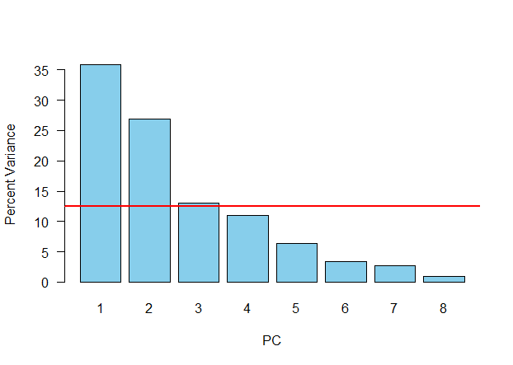

**Analysis-** The scree plot data shows that at least first three components (PC1, PC2, PC3) is required to analyse the principle components.

**Step 6-** # Constructing Biplot with arrows

round(loadings, 2)

round(loadings, 2)[ , 1:3]

biplot(scores[, 1:2], loadings[, 1:2], cex=0.7)

plot(scores[, 1], scores[, 2], xlab='PC 1', ylab='PC 2', type='n', xlim=c(min(scores[, 1:2]), max(scores[, 1:2])), ylim=c(min(scores[, 1:2]), max(scores[, 1:2])), las=1)

text(scores[, 1],scores[, 2], rownames(scores), col='gray', cex=0.7)

scale <- 5

arrows(0, 0, loadings[, 1]*scale, loadings[, 2]*scale, length=0.1, angle=20, col='red')

labelScale <- 1.2

text(loadings[, 1]*scale*labelScale, loadings[, 2]*scale* labelScale, rownames(loadings), col='red', cex=0.7)

**Result-**

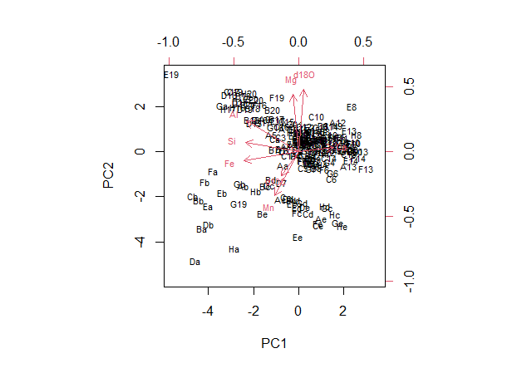

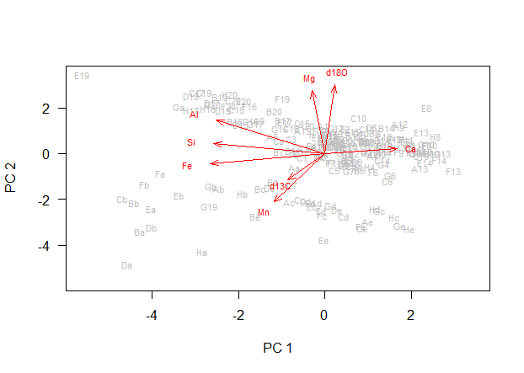

**Analysis-** The biplot values of the PCA shows the sample names with arrows shows the variable on each axis. A scaling factor is added to modify the arrow length. The length of the arrow defines the weight of the loading vector.

**Step 7-** # Classifying Crater formation and Hermitage Formation using unsupervised classification of the geochemical PCA data.

Carters <- nashville$StratPosition < 34.2

Hermitage <- nashville$StratPosition > 34.2

plot(scores[, 1], scores[, 2], xlab='PC 1', ylab='PC 2', type='n', asp=1, las=1)

points(scores[Carters, 1], scores[Carters, 2], pch=16, cex=0.7, col='blue')

points(scores[Hermitage, 1], scores[Hermitage, 2], pch=16, cex=0.7, col='red')

text(1, 3, 'Carters', col='blue')

text(-1, -4, 'Hermitage', col= 'red')

**Result-**

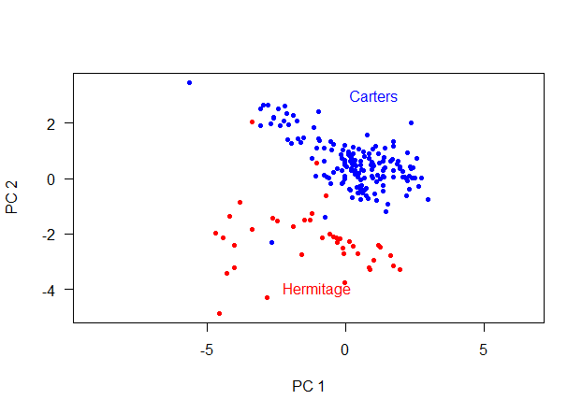

**Analysis-** The craters and hermitage formation are differentiated by unsupervised classification based on the PCA data.

**Step 8-** # Constructing Correlations Biplot and Correlation Matrix

sd <- pca$sdev

plot(scores[, 1]/sd[1], scores[, 2]/sd[2], xlab='PC 1', ylab='PC 2', type='n', las=1)

text(scores[, 1]/sd[1],scores[, 2]/sd[2], rownames(scores), col='gray', cex=0.7)

arrows(0, 0, loadings[, 1]*sd[1], loadings[, 2]*sd[2],

length=0.1, angle=20, col='red')

labelScale <- 1.2

text(loadings[, 1]*sd[1]* labelScale, loadings[, 2]*sd[2]* labelScale, rownames(loadings), col='red', cex=0.7)

biplot(pca)

sd <- pca$sdev

correlations <- t(loadings) * sd

correlations <- cor(scores, geochem)

install.packages("ggcorrplot")

library(ggcorrplot)

corr_matrix = round(cor(correlations), 2)

ggcorrplot(corr_matrix, hc.order = TRUE, type = "lower", lab = TRUE)

**Results-**

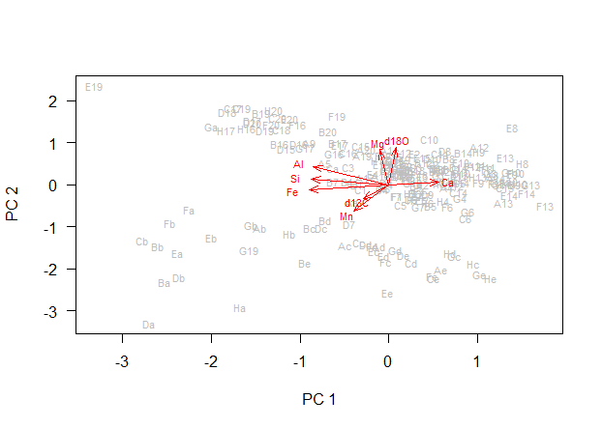

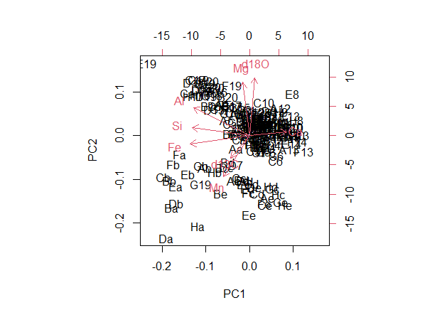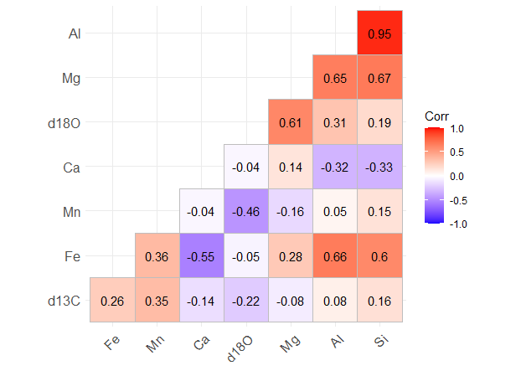

**Analysis-** The biplot data shows the correlation of the geochemical variables with the PC1 and PC2. The variables are either positively correlated or negatively correlated with the principle components. The Correlation matrix shows the correlation among the geochemical variables Principle Components. There is the strongest correlation between Al and Si.